Uncertainty Intervals

By default Prophet will return uncertainty intervals for the forecast ***yhat***. 默认情况下，Prophet将为预测***yhat***返回不确定性区间。(Quick_start中，我们预测值有额外的 yhat_upper和yhat_lower)

There are several important assumptions behind these uncertainty intervals.z这些不确定区间中间有几个重要的假设。

There are three sources of uncertainty in the forecast: uncertainty in the trend, uncertainty in the seasonality estimates, and additional observation noise. 预测的不确定性有三个来源:趋势的不确定性、季节性估计的不确定性和额外的观测噪声

# Uncertainty in the trend/ 趋势中的不确定区间

**The biggest source of uncertainty in the forecast is the potential for future trend changes. 预测中最大的不确定性来源是未来趋势变化的可能性。**The time series we have seen already in this documentation show clear trend changes in the history. Prophet is able to detect and fit these, but what trend changes should we expect moving forward? Prophet能够检测和拟合这些，但到底什么样的趋势是我们真正期待的。 It’s impossible to know for sure, so we do the most reasonable thing we can, and we assume that the *future will see similar trend changes as the history*. 这是不可能确切知道的，所以我们尽我们所能做最合理的事情，我们假设未来会看到与历史相似的趋势变化。 In particular, we assume that the average frequency and magnitude of trend changes in the future will be the same as that which we observe in the history. 特别是，我们假设未来趋势变化的**平均频率和幅度**将与我们在历史上观察到的相同。We project these trend changes forward and by computing their distribution we obtain uncertainty intervals. 我们预测这些趋势变化，通过计算它们的分布，我们得到了不确定性区间。

One property of this way of measuring uncertainty is that allowing higher flexibility in the rate, by increasing ***changepoint_prior_scale***, will increase the forecast uncertainty. 这种测量不确定性的方法的一个特性是，通过增加changepoint_prior_scale，允许比率的更高灵活性，将增加预测的不确定性。This is because if we model more rate changes in the history then we will expect more in the future, and makes the uncertainty intervals a useful indicator of overfitting. 这是因为如果我们对历史上更多的比率变化进行建模，那么我们对未来的预期就会更多，并使不确定性区间成为过拟合的有用指标。

**【注】默认情况下，changepoint_prior_scale为0.05**

**# changepoint_prior_scale 越大会使得趋势变化更加灵活（拟合性越好）**

The width of the uncertainty intervals (by default 80%) can be set using the parameter ***interval_width***:

不确定性区间的宽度(默认为80%)可以使用参数***interval_width***设置(值越小，上下限的带宽越小)

1. # Python
2. forecast = Prophet(interval_width=0.95).fit(df).predict(future)

Again, these intervals assume that the future will see the same frequency and magnitude of rate changes as the past. This assumption is probably not true, so you should not expect to get accurate coverage on these uncertainty intervals. 同样，这些区间假设未来利率变化的频率和幅度与过去相同。这个假设可能是不正确的，所以您不应该期望在这些不确定性区间上得到准确的覆盖。

# Uncertainty in seasonality/ 季节性中的不确定性

By default Prophet will only return uncertainty in the trend and observation noise. 默认情况下，Prophet只会返回趋势中不确定性和观测噪声。To get uncertainty in seasonality, you must do full Bayesian sampling.为了获取季节性的不确定性，必须进行完整的贝叶斯抽样 **This is done using the parameter mcmc.samples (which defaults to 0).使用mcmc.samples** We do this here for the first six months of the Peyton Manning data from the Quickstart:

1. # Python
2. m = Prophet(mcmc_samples=300)
3. forecast = m.fit(df, show_progress=False).predict(future)

This replaces the typical MAP estimation with MCMC sampling, and can take much longer depending on how many observations there are - expect several minutes instead of several seconds. **这将用MCMC采样取代典型的MAP估计，并且可能需要更长的时间，这取决于有多少观测数据——预计几分钟而不是几秒钟。**If you do full sampling, then you will see the uncertainty in seasonal components when you plot them: 如果你做全采样，那么当你绘制季节成分时，你会看到它们的不确定性。

1. # Python
2. fig = m.plot_components(forecast)

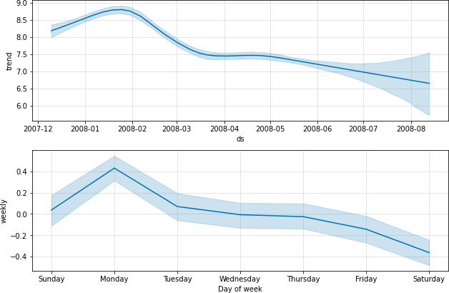

You can access the raw posterior predictive samples in Python using the method

**m.predictive_samples(future)**

[Edit on GitHub](https://github.com/facebook/prophet/blob/main/docs/_docs/uncertainty_intervals.md)